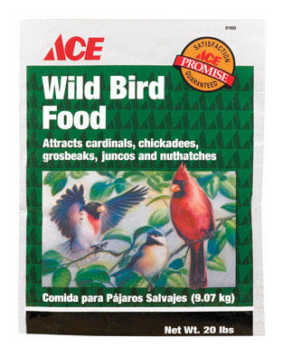
Wild Bird Food

- 20 Ibs
- With added vitamins and minerals
- Attracts Cardinals, Chickadees, Grosbeaks, Juncos and Nuthatches

$6.99
81995

